Level-6

Final Project

“Document Repository”

By

Gurpreet Singh

Table of Contents

Project Proposal 3

Goals and Objectives 3

Project Scope 3

Project Deliverables 3

Project Specifications 3

Target Audience 4

Project Tasks and Milestones 4

Resource Requirements 6

Project Risks 6

Software Project Report 7

Analysis 7

Requirements Analysis 7

Detail Design 8

Home Page 8

Registration Page 9

Login Page 10

All Documents Page Admin View 10

Publisher Page Admin View 10

Document Log Page Admin View 11

My Documents Page 11

Publisher Signup Page 12

Project Testing 13

System Usability Testing 13

Testing 13

User Manual 16

General Information 16

System Overview 16

System Summary 16

System Configuration 16

User Access Levels 16

# Project Proposal

## Goals and Objectives

The goal of this project is to implement an online document repository application. With the help of which one can upload the documents to the cloud. In this application, there are two types of user admin and publisher. Admin has the right to edit, delete, and access the details of all documents. Admin can edit, delete, and access details of publishers and can delete and access details of the document logs. While, a publisher can only add documents, edit, delete, and access the details of the documents. New Publishers can sign up and admin can register new admins for the site.

## Project Scope

This is a 20 days project in which I have implemented an online document repository application. The scope of this project is to help the publisher to add their documents to the cloud so that they can access it anywhere anytime. New publisher can register themselves to the application.

## Project Deliverables

This project will require certain deliverables. The table below outlines these deliverables.

|  |  |
| --- | --- |
| **Deliverable** | **Description** |
| Final Report | This document. Introduces the project and elaborates its details and requirements. It also states the milestone, schedule, hardware and software requirement, and other important details. |
| Executable Programme | This will be the executable code of the project. |
| User Documentation | This will show how one can use the web application |
| Test Plan | This will provide the test detail of the project |

## Project Specifications

* Secure login and registration by publisher.
* Edit, delete, and access details of all documents by the admin.
* Admin can edit, delete, and access details of publishers.
* Admin can delete and access details of the document logs.
* Publisher can add documents, edit, delete and access details of the documents,

## Target Audience

Normal users and anyone who is keen to secure and save their data on the cloud age from 14 years and can go up to 100 years.

## Project Tasks and Milestones

|  |  |  |  |  |  |  |  |  |  |  |  |  |  |  |  |
| --- | --- | --- | --- | --- | --- | --- | --- | --- | --- | --- | --- | --- | --- | --- | --- |
| Project Stages | Major Activities | Week1-2 | | | | Week-2-3 | | | | | Week-3-4 | | | | |
| Planning | Technology Research |  |  |  |  |  |  |  |  |  |  |  |  |  |  |
| Kick-off Meeting |  |  |  |  |  |  |  |  |  |  |  |  |  |  |
| Project Proposal and documentation |  |  |  |  |  |  |  |  |  |  |  |  |  |  |
| Execution | Database Design |  |  |  |  |  |  |  |  |  |  |  |  |  |  |
| User Interface Design |  |  |  |  |  |  |  |  |  |  |  |  |  |  |
| Identity Framework implementation |  |  |  |  |  |  |  |  |  |  |  |  |  |  |
| User Interface Implementation |  |  |  |  |  |  |  |  |  |  |  |  |  |  |
| Admin Interface Implementation |  |  |  |  |  |  |  |  |  |  |  |  |  |  |
| Testing |  |  |  |  |  |  |  |  |  |  |  |  |  |  |
| Closing | Final Documentation |  |  |  |  |  |  |  |  |  |  |  |  |  |  |

## Resource Requirements

Following technologies and development method:

* Asp.net MVC Framework
* Identity framework- ASP
* Windows Operating System
* 64-bit Processor and 4 GB RAM
* Microsoft Word Processor.

## Project Risks

The following are the identified high-level risks that might affect the completion and success of the project:

* One admin and publisher will be registered by default.
* Project interruptions may cause flowing suspension in other dependent tasks.
* Project scope and duration may be miscalculated.

|  | **Low (Yes)** | | | | **RISK** | | | | **(No) High** | | | |
| --- | --- | --- | --- | --- | --- | --- | --- | --- | --- | --- | --- | --- |
| 0 | 1 | 2 | 3 | | 4 | 5 | 6 | | 7 | 8 | 9 |
| **Inherent Risks** |  |  |  |  | |  |  |  | |  |  |  |
| **Project Objectives** |  |  |  |  | |  |  |  | |  |  |  |
| Is the project small? |  |  |  |  | |  |  |  | | **●** |  |  |
| Is the project of minor importance to the business? |  |  |  |  | |  |  | **●** | |  |  |  |
| Is the project functionally straightforward? |  |  |  |  | |  |  |  | |  | **●** |  |
| Is the subject area well documented? |  |  | **●** |  | |  |  |  | |  |  |  |
| **User Organisation** |  |  |  |  | |  |  |  | |  |  |  |
| Does the project maintain existing user procedures? |  | **●** |  |  | |  |  |  | |  |  |  |
| **Technology** |  |  |  |  | |  |  |  | |  |  |  |
| Is tried hardware being used? |  | **●** |  |  | |  |  |  | |  |  |  |
| Is the project technically straightforward? |  |  |  |  | |  |  |  | |  | **●** |  |
| Is the quality of existing data good? | **●** |  |  |  | |  |  |  | |  |  |  |
| **Acquired Risks** |  |  |  |  | |  |  |  | |  |  |  |
| **Scope and Approach** |  |  |  |  | |  |  |  | |  |  |  |
| Is the project scope well defined and agreed? |  | **●** |  |  | |  |  |  | |  |  |  |
| Is the project approach well defined and agreed? |  | **●** |  |  | |  |  |  | |  |  |  |
| **Experience, Training and Support** |  |  |  |  | |  |  |  | |  |  |  |
| Does the IT team know the technology? |  |  |  |  | |  | **●** |  | |  |  |  |
| Do the users know the technology? |  |  |  |  | |  | **●** |  | |  |  |  |
| Is the technology well supported? |  |  | **●** |  | |  |  |  | |  |  |  |

# Software Project Report

## Analysis

### Requirements Analysis

The requirement analysis covers the functional and non-functional aspects of the system.

#### Functional

The functional requirements of this project are divided into types. One for Admin, and one for Publisher.

|  |  |
| --- | --- |
| **Users** | **Functional Requirements** |
| **Admin** | * Login/logout * Manage all documents, publisher and document logs * Add, delete, edit, and access details of all documents. * Edit, delete, and access details of publishers. * Delete and access details of document logs. * Add/register new admins. |
| **Publisher** | * Login/logout * Register as new user * Add new documents. * Edit, delete, and access details of the existing documents. |

#### Non-Functional

|  |  |
| --- | --- |
| **Operational** | * The system should able to run on all web browsers. * The system should be accessible via mobiles |
| **Performance** | * The system should have a 99% uptime |
| **Security** | * Only Administrators have full access to the system * Publisher can have access to their accounts only. |

## Detail Design

### Home Page

This is the main landing page of the application. On this page in the navigation there are 5 menus- home, documents, publisher sign up, login, and create a Repo admin.

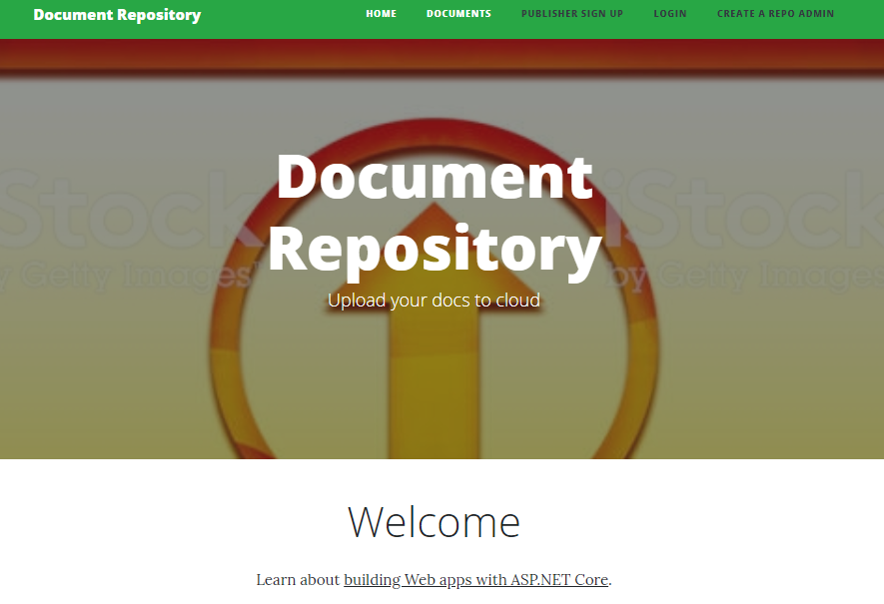

### Registration Page

With the help of this page admin can register new admins for the web application.

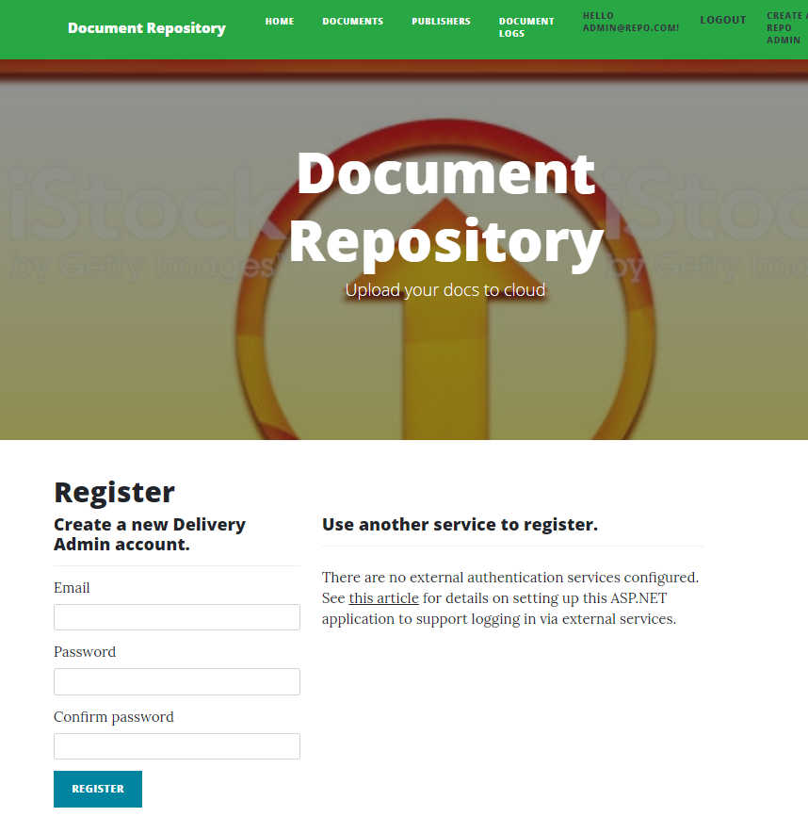

### Login Page

All register admins and publishers can login using this page. This is common between publisher and admin.

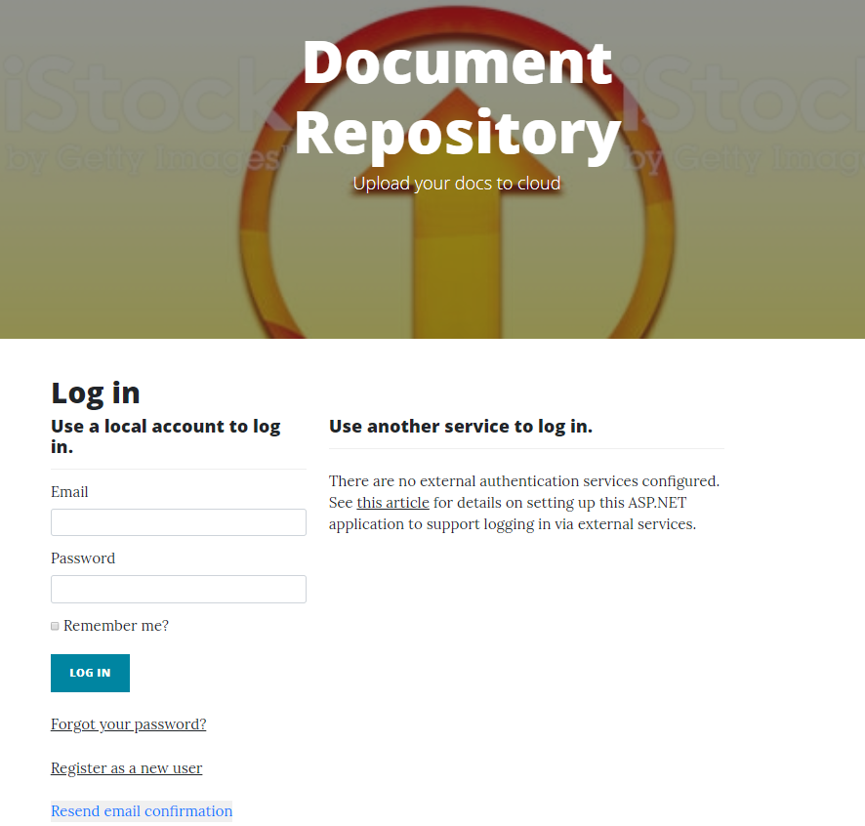

### All Documents Page Admin View

With the help of this page admin can manage all documents on the web application by edit, deleting and accessing the details.

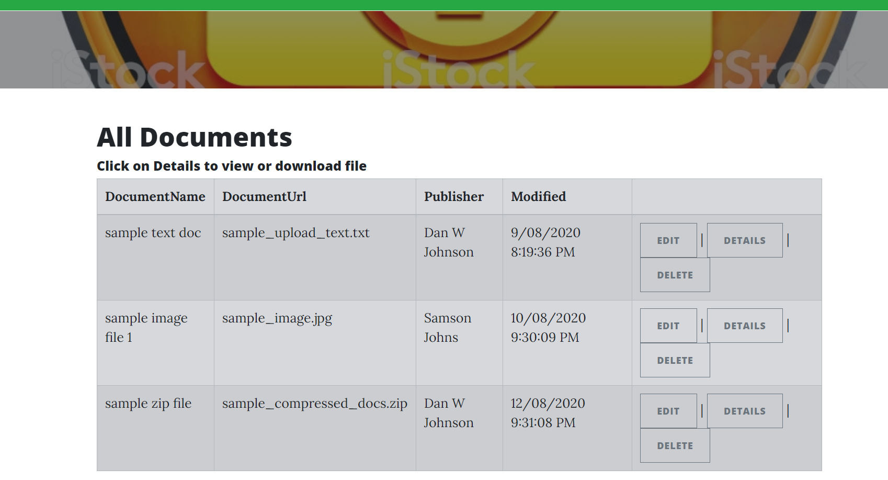

### Publisher Page Admin View

This page will highlight the details of the registered publishers. Admin can edit, delete and access the details of the publishers.

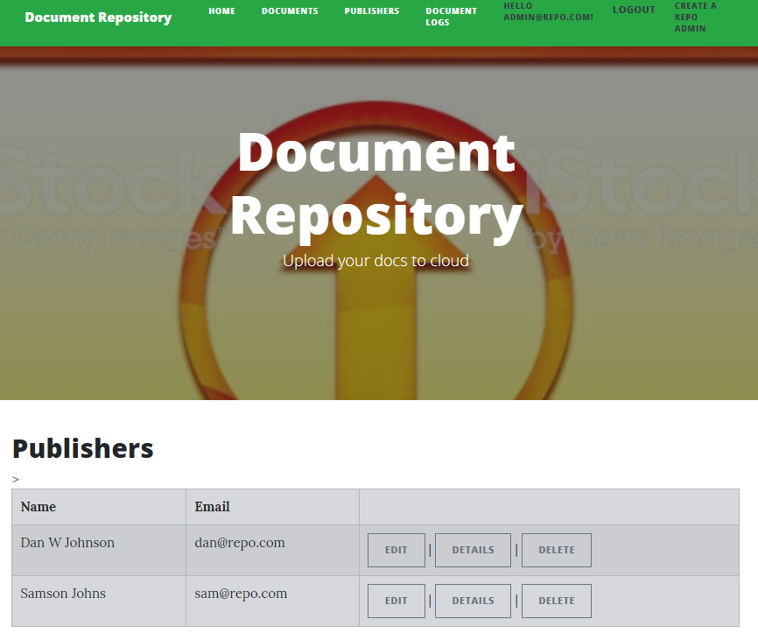

### Document Log Page Admin View

With the help of this page admin can edit, and delete document logs..

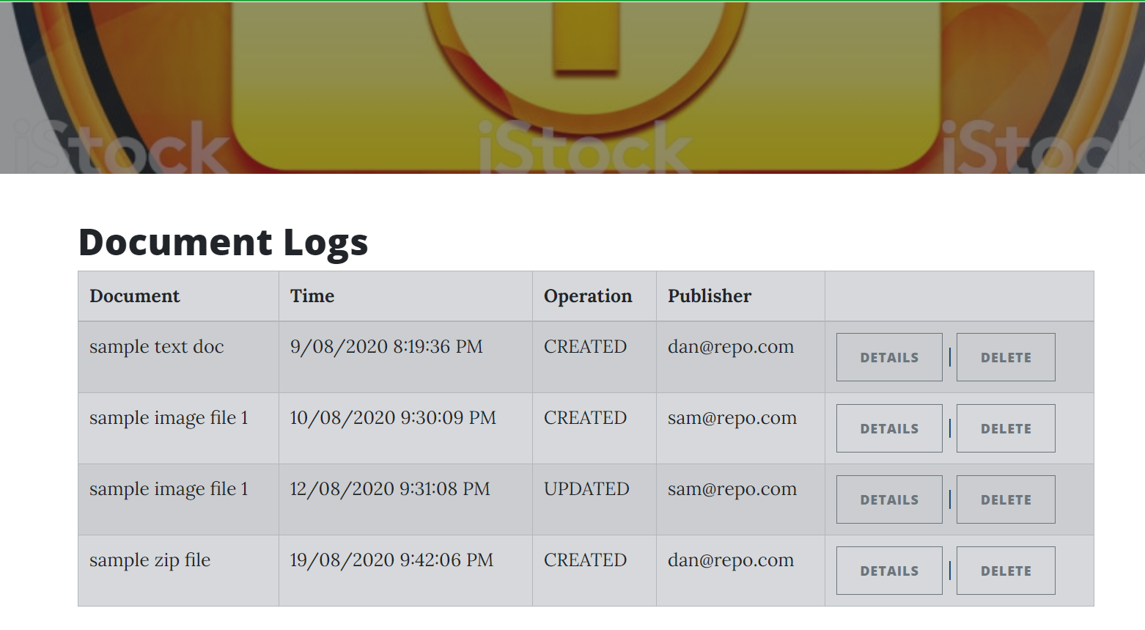

### My Documents Page

Using this page publishers can add documents, edit, delete, and access details of their documents.

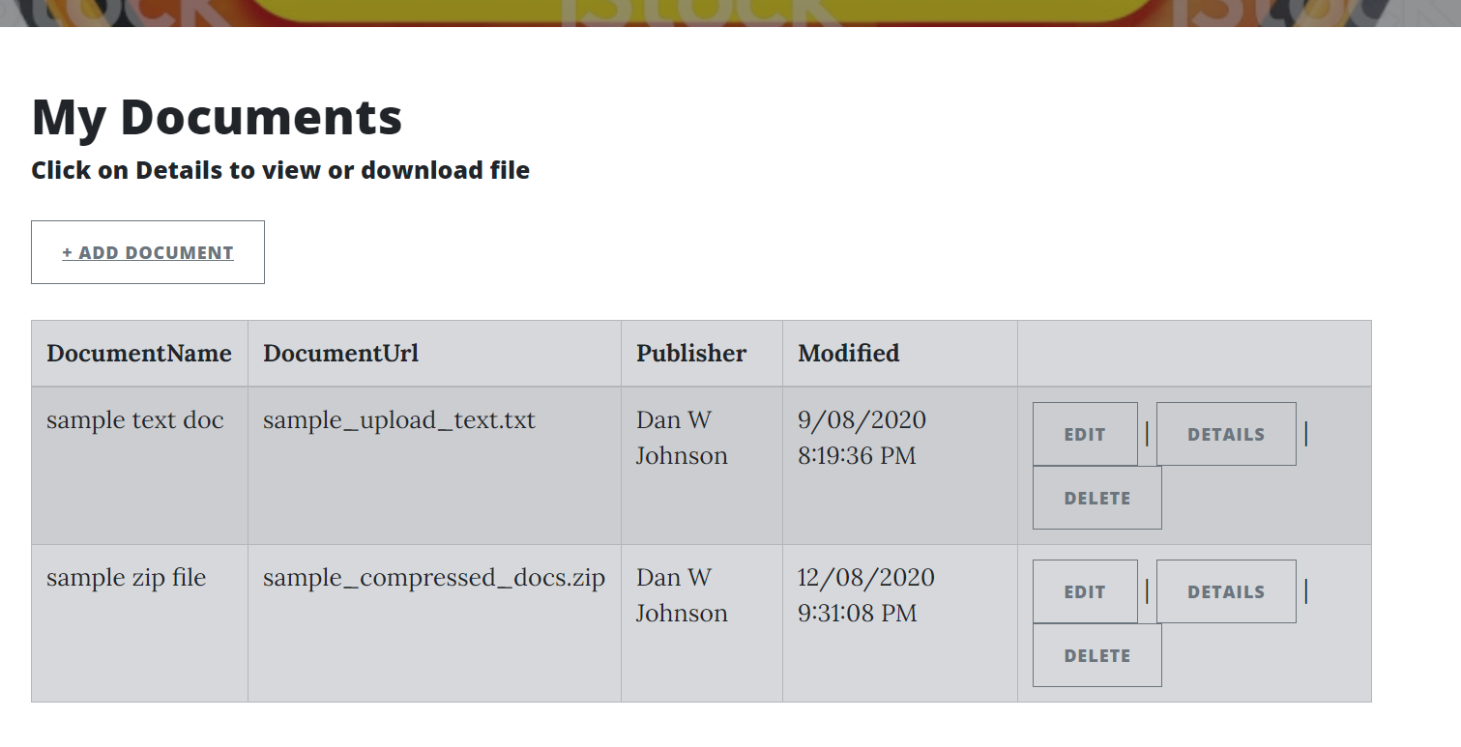

### Publisher Signup Page

With the help of this page, a new publisher can register for the application for free.

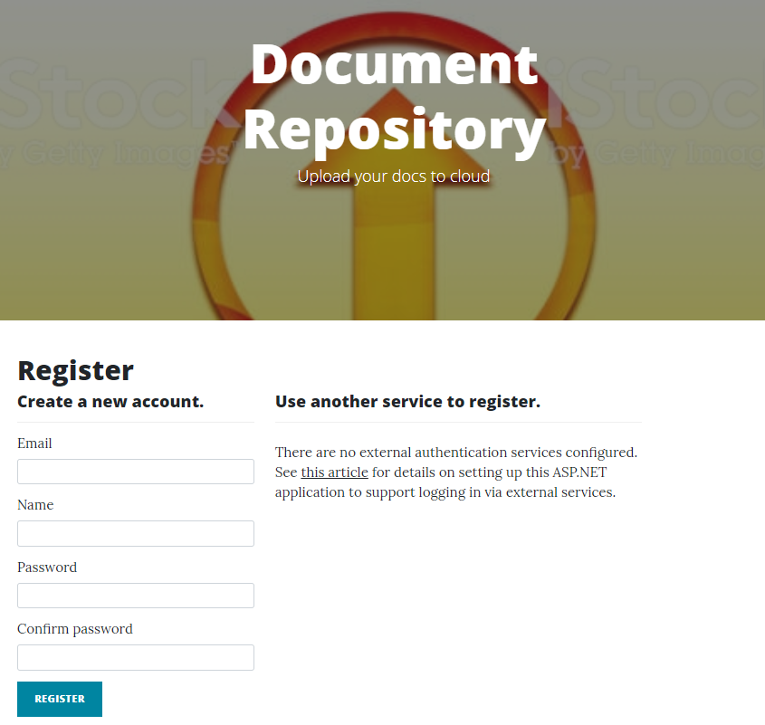

# Project Testing

## System Usability Testing

### Testing

**Tester 1**

|  |  |  |  |  |  |  |
| --- | --- | --- | --- | --- | --- | --- |
| **Tester – 1** | | **Answer Scale** | | | | |
| **No.** | **Question** | **Strongly Disagree (1)** | **Disagree (2)** | **Normal (3)** | **Agree (4)** | **Strongly Agree (5)** |
| 1 | I think that I would like to use this system frequently |  |  |  |  |  |
| 2 | I found the system unnecessarily complex |  |  |  |  |  |
| 3 | I thought the system was easy to use |  |  |  |  |  |
| 4 | I think that I would need the support of a technical person to be able to use this system |  |  |  |  |  |
| 5 | I found the various functions in this system were well integrated |  |  |  |  |  |
| 6 | I thought there was too much inconsistency in this system |  |  |  |  |  |
| 7 | I would imagine that most people would learn to use this system very quickly |  |  |  |  |  |
| 8 | I found the system very cumbersome to use |  |  |  |  |  |
| 9 | I felt very confident using the system |  |  |  |  |  |
| 10 | I needed to learn a lot of things before I could get going with this system |  |  |  |  |  |

**Tester 2**

|  |  |  |  |  |  |  |
| --- | --- | --- | --- | --- | --- | --- |
| **Tester –2** | | **Answer Scale** | | | | |
| **No.** | **Question** | **Strongly Disagree (1)** | **Disagree (2)** | **Normal (3)** | **Agree (4)** | **Strongly Agree (5)** |
| 1 | I think that I would like to use this system frequently |  |  |  |  |  |
| 2 | I found the system unnecessarily complex |  |  |  |  |  |
| 3 | I thought the system was easy to use |  |  |  |  |  |
| 4 | I think that I would need the support of a technical person to be able to use this system |  |  |  |  |  |
| 5 | I found the various functions in this system were well integrated |  |  |  |  |  |
| 6 | I thought there was too much inconsistency in this system |  |  |  |  |  |
| 7 | I would imagine that most people would learn to use this system very quickly |  |  |  |  |  |
| 8 | I found the system very cumbersome to use |  |  |  |  |  |
| 9 | I felt very confident using the system |  |  |  |  |  |
| 10 | I needed to learn a lot of things before I could get going with this system |  |  |  |  |  |

**Tester 3**

|  |  |  |  |  |  |  |
| --- | --- | --- | --- | --- | --- | --- |
| **Tester – 3** | | **Answer Scale** | | | | |
| **No.** | **Question** | **Strongly Disagree (1)** | **Disagree (2)** | **Normal (3)** | **Agree (4)** | **Strongly Agree (5)** |
| 1 | I think that I would like to use this system frequently |  |  |  |  |  |
| 2 | I found the system unnecessarily complex |  |  |  |  |  |
| 3 | I thought the system was easy to use |  |  |  |  |  |
| 4 | I think that I would need the support of a technical person to be able to use this system |  |  |  |  |  |
| 5 | I found the various functions in this system were well integrated |  |  |  |  |  |
| 6 | I thought there was too much inconsistency in this system |  |  |  |  |  |
| 7 | I would imagine that most people would learn to use this system very quickly |  |  |  |  |  |
| 8 | I found the system very cumbersome to use |  |  |  |  |  |
| 9 | I felt very confident using the system |  |  |  |  |  |
| 10 | I needed to learn a lot of things before I could get going with this system |  |  |  |  |  |

# User Manual

## General Information

### System Overview

With the help of an online application called “document repository,” one can upload the documents to the cloud. In this application, there are two types of user admin and publisher. Admin has the right to edit, delete, and access the details of all documents. Admin can edit, delete, and access details of publishers and can delete and access details of the document logs. While, the publisher can only add documents, edit, delete, and access the details of the documents. New Publishers can sign up and admin can register new admins for the site.

## System Summary

### System Configuration

Document Repository is a web application developed using Asp.net MVC Framework. It will run on most modern web browsers and will not require any special system configuration. As a web application, it will require an internet connection to function.

### User Access Levels

Only registered users can access the features of the Document Repository.

* **Admin:** Full access to the system and all functionalities.
* **Users:** Limited access to the app. Admin can only see their accounts and manage documents.